Lagged cross-correlation: USDCHF and USDCAD
Method 12 / daily log returns / K_max=10 / Alpari D1 full available history

Study setup
Logical pair: USDCHF , USDCAD
Broker symbols: USDCHF_i , USDCAD_i
Snapshot: 2026-11-03_majors_alpari_D1
Timeframe: D1
Matched return window: 1999-01-05 to 2026-11-02 (UTC bar dates)
Matched return count n: 7188
Dropped unfinished last bar dated 2026-11-03 UTC after a tick-volume check against the prior complete day.
Lag definition: rho_X->Y(k) = Corr(x_t, y_{t+k}) on matched D1 bars
K_max = 10; headline lag k = 1 (both directions)
Complete matched rows (Excel): USDCHF-USDCAD_Lagged_D1.xlsx
Complete matched rows (HTML table): USDCHF-USDCAD_Lagged_D1_data.html

Method carried forward
Lagged cross-correlation measures Pearson correlation between matched daily log returns of close, ln(close_t / close_t-1), after shifting one series forward by k bars on the matched panel. Quotes are not inverted. rho_{X->Y}(k) = Corr(x_t, y_{t+k}) with n_k = n - k. K_max = 10 is fixed before estimation. The headline is the pre-specified lag k = 1 in both directions. k = 0 is the same-bar side check. The lag inside 1..10 with the largest absolute rho is stored as a descriptive column only; it is not a selected result. This is a linear screen, not proof of forecast edge, economic cause, or a trading signal.

Results (headline k=1)
rho_USDCHF->USDCAD(1): -0.049411 (n=7187)
95% Fisher interval USDCHF->USDCAD: [-0.072448, -0.026321]
rho_USDCAD->USDCHF(1): 0.031676 (n=7187)
95% Fisher interval USDCAD->USDCHF: [0.008562, 0.054756]
Same-bar rho(k=0): 0.304665
Largest |rho| among k=1..10 (descriptive only, not selected): USDCHF->USDCAD k=1 rho=-0.049411; USDCAD->USDCHF k=1 rho=0.031676

CCF table
k | rho_USDCHF_to_USDCAD | n_USDCHF_to_USDCAD | rho_USDCAD_to_USDCHF | n_USDCAD_to_USDCHF
0 | 0.30466523 | 7188 | 0.30466523 | 7188
1 | -0.04941054 | 7187 | 0.03167579 | 7187
2 | 0.02182585 | 7186 | 0.01022641 | 7186
3 | -0.0204013 | 7185 | -0.0117595 | 7185
4 | -0.00482091 | 7184 | 0.01510136 | 7184
5 | -0.01180334 | 7183 | 0.01568381 | 7183
6 | 0.00526395 | 7182 | 0.01035729 | 7182
7 | -0.01285516 | 7181 | -0.00890368 | 7181
8 | 0.00729382 | 7180 | 0.02987785 | 7180
9 | -0.00952639 | 7179 | -0.02775921 | 7179
10 | -0.01066656 | 7178 | 0.00235965 | 7178

Conclusion
At the pre-specified lag k=1 for USDCHF and USDCAD, rho_{USDCHF->USDCAD}(1) = -0.0494 (n=7187) and rho_{USDCAD->USDCHF}(1) = 0.0317 (n=7187). Same-bar rho(k=0) = 0.3047. Largest |rho| among k=1..10 is descriptive only: USDCHF->USDCAD at k=1 (-0.0494); USDCAD->USDCHF at k=1 (0.0317). This is a linear screen, not forecast proof or a trading signal.

Charts
Daily closes

Daily log returns

CCF both directions k=0..10
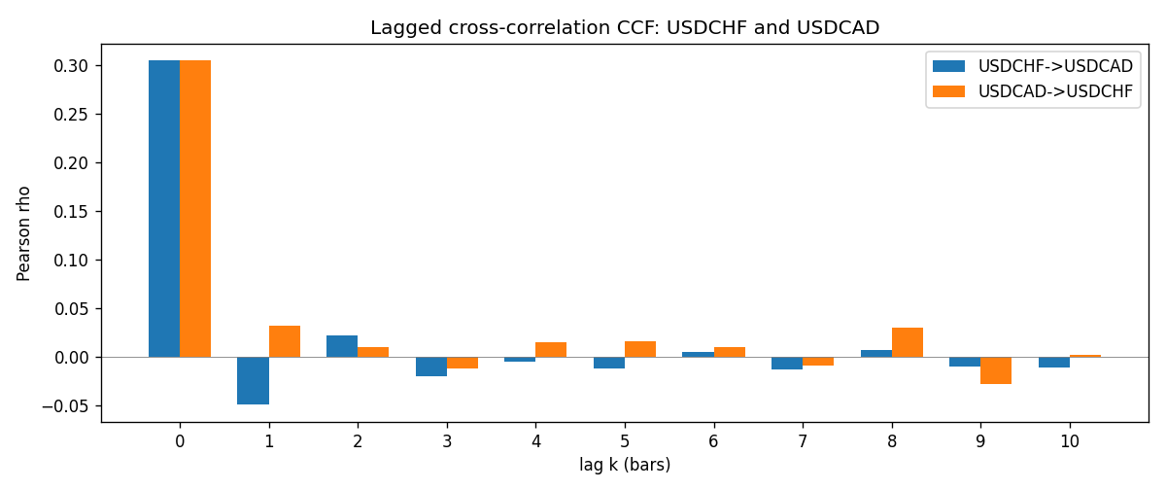

Data report
Every matched row is stored in the sibling Excel workbook named USDCHF-USDCAD_Lagged_D1.xlsx (sheet matched_rows). The CCF sheet holds rho(k) for k=0..10. Embedding all rows as a Word table is impractical; the Word file holds column summaries and the first and last 15 rows.
Columns: time, USDCHF_open, USDCAD_open, USDCHF_high, USDCAD_high, USDCHF_low, USDCAD_low, USDCHF_close, USDCAD_close, USDCHF_tick_volume, USDCAD_tick_volume, USDCHF_spread, USDCAD_spread, USDCHF_real_volume, USDCAD_real_volume, USDCHF_log_return, USDCAD_log_return
Column summaries (matched calculation rows)
column | count | mean | std | min | 25% | 50% | 75% | max
USDCHF_open | 7188 | 1.0975966 | 0.25229688 | 0.72022 | 0.9205375 | 0.989955 | 1.2378 | 1.8219
USDCAD_open | 7188 | 1.2667824 | 0.16892678 | 0.9168 | 1.1183975 | 1.298465 | 1.3720475 | 1.6183
USDCHF_high | 7188 | 1.1028875 | 0.2540352 | 0.73305 | 0.924845 | 0.993545 | 1.242375 | 1.8313
USDCAD_high | 7188 | 1.2716804 | 0.16888565 | 0.9336 | 1.12285 | 1.30387 | 1.37646 | 1.619
USDCHF_low | 7188 | 1.0924772 | 0.25071604 | 0.08565 | 0.91725 | 0.9863 | 1.23155 | 1.8121
USDCAD_low | 7188 | 1.2622243 | 0.16896256 | 0.9056 | 1.114065 | 1.293535 | 1.3677775 | 1.6102
USDCHF_close | 7188 | 1.0975873 | 0.25219296 | 0.72025 | 0.920805 | 0.98995 | 1.2379 | 1.8217
USDCAD_close | 7188 | 1.2667976 | 0.16890032 | 0.916 | 1.118075 | 1.29844 | 1.372365 | 1.6137
USDCHF_tick_volume | 7188 | 74305.244 | 113479.97 | 1 | 12787.25 | 40220 | 70419.75 | 858589
USDCAD_tick_volume | 7188 | 81017.898 | 147302.44 | 1 | 5560 | 40941.5 | 71627 | 1410818
USDCHF_spread | 7188 | 26.050501 | 24.7086 | 0 | 5 | 16 | 50 | 100
USDCAD_spread | 7188 | 23.4399 | 18.261108 | 0 | 9 | 17 | 40 | 60
USDCHF_real_volume | 7188 | 2.3284369e+10 | 8.9116261e+10 | 0 | 0 | 0 | 0 | 1.9331921e+12
USDCAD_real_volume | 7188 | 1.8376704e+10 | 9.6688094e+10 | 0 | 0 | 0 | 0 | 2.5751613e+12
USDCHF_log_return | 7188 | -7.133e-05 | 0.00659527 | -0.19545699 | -0.0033544 | 8.077e-05 | 0.00332477 | 0.09051364
USDCAD_log_return | 7188 | -1.556e-05 | 0.00514382 | -0.03859748 | -0.00283746 | 4.44e-05 | 0.00272629 | 0.03436319
First 15 matched rows (selected columns)
time | USDCHF_close | USDCAD_close | USDCHF_log_return | USDCAD_log_return
1999-01-05 | 1.3724 | 1.5123 | 0.0039424743 | -0.010131666
1999-01-06 | 1.3912 | 1.5118 | 0.013605652 | -0.0003306769
1999-01-07 | 1.3782 | 1.5141 | -0.0093883841 | 0.0015202092
1999-01-08 | 1.3935 | 1.511 | 0.011040268 | -0.0020495197
1999-01-11 | 1.4009 | 1.5057 | 0.0052963193 | -0.0035137769
1999-01-12 | 1.3872 | 1.5157 | -0.0098275602 | 0.0066194721
1999-01-13 | 1.3621 | 1.5226 | -0.018259701 | 0.0045420214
1999-01-14 | 1.3588 | 1.5332 | -0.0024256692 | 0.0069376546
1999-01-15 | 1.3834 | 1.5245 | 0.01794228 | -0.0056905671
1999-01-18 | 1.379 | 1.526 | -0.0031856384 | 0.00098344542
1999-01-19 | 1.3789 | 1.5302 | -7.2518946e-05 | 0.002748513
1999-01-20 | 1.3889 | 1.5211 | 0.0072259871 | -0.0059646885
1999-01-21 | 1.3836 | 1.5146 | -0.0038232689 | -0.0042823796
1999-01-22 | 1.3834 | 1.5184 | -0.0001445609 | 0.0025057712
1999-01-25 | 1.3868 | 1.5197 | 0.0024546976 | 0.00085579808
Last 15 matched rows (selected columns)
time | USDCHF_close | USDCAD_close | USDCHF_log_return | USDCAD_log_return
2026-10-13 | 0.83244 | 1.4214 | -0.0024955621 | -0.0046395653
2026-10-14 | 0.83489 | 1.42356 | 0.0029388325 | 0.0015184751
2026-10-15 | 0.82676 | 1.41843 | -0.0097855323 | -0.0036101503
2026-10-16 | 0.82377 | 1.41357 | -0.0036230826 | -0.0034322068
2026-10-19 | 0.82677 | 1.41091 | 0.0036351779 | -0.0018835331
2026-10-20 | 0.8246 | 1.40569 | -0.0026281224 | -0.0037066008
2026-10-21 | 0.82427 | 1.4045 | -0.00040027413 | -0.00084691787
2026-10-22 | 0.82032 | 1.40081 | -0.0048036381 | -0.0026307268
2026-10-23 | 0.82497 | 1.40085 | 0.005652514 | 2.85545e-05
2026-10-26 | 0.82649 | 1.40093 | 0.0018407959 | 5.7106554e-05
2026-10-27 | 0.82865 | 1.40449 | 0.0026100526 | 0.0025379458
2026-10-28 | 0.82781 | 1.39911 | -0.0010142111 | -0.0038379274
2026-10-29 | 0.82379 | 1.39895 | -0.0048680164 | -0.00011436495
2026-10-30 | 0.82438 | 1.39751 | 0.00071594559 | -0.0010298736
2026-11-02 | 0.81851 | 1.39837 | -0.0071459744 | 0.00061519094

